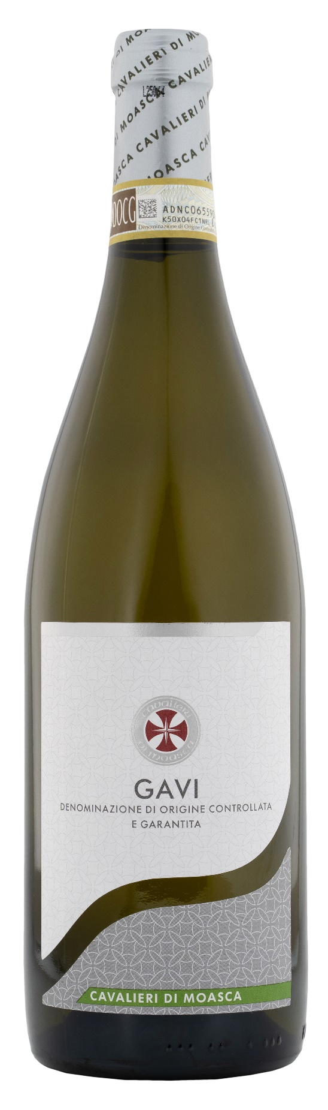
GAVI DOCG – CAVALIERI DI MOASCA

Grape: Cortese 100%
Alc. Vol.%: 12,5
Vintage: 2025
Residual sugar g/l: 1,0
Total acidity g/l: 5,5
Region: Piedmont
Production zone: Vineyards in the area of Gavi (Alessandria)
Capacity: 750ml

CHARACTERISTICS

Vinification: Soft pressing, fermentation in stainless steel tanks at controlled temperature of 16-18°C for 10 days
Aging: In steel tanks until bottling
Yield per ha: 8000kg
Colour: Straw-yellow with greenish sparkles
Bouquet: Delicate, floral and slightly mineral
Flavour: Dry, subtle and harmonious

SERVING SUGGESTIONS

Best enjoyed with fish, seafood and delicate soups.
Serving temperature 8-10 °C
TECHNICAL INFORMATION / PALLETIZING

Size 750ml:
Article Nr. V06007A
GTIN-13 bottle 8017868003090
GTIN-13 carton 8017868002178
Closure Cork
Bottles / carton 6 bottles
Pallet size 80x120cm
Cartons/layer 21
Cartons/pallet 105
Kg/carton 7,8
Kg/pallet 870

Contains sulphites
GMO Free
Revisione 01. 14.10.2026

